1. **Agenda**:  
   Why it’s crucial to have wildcard?
2. 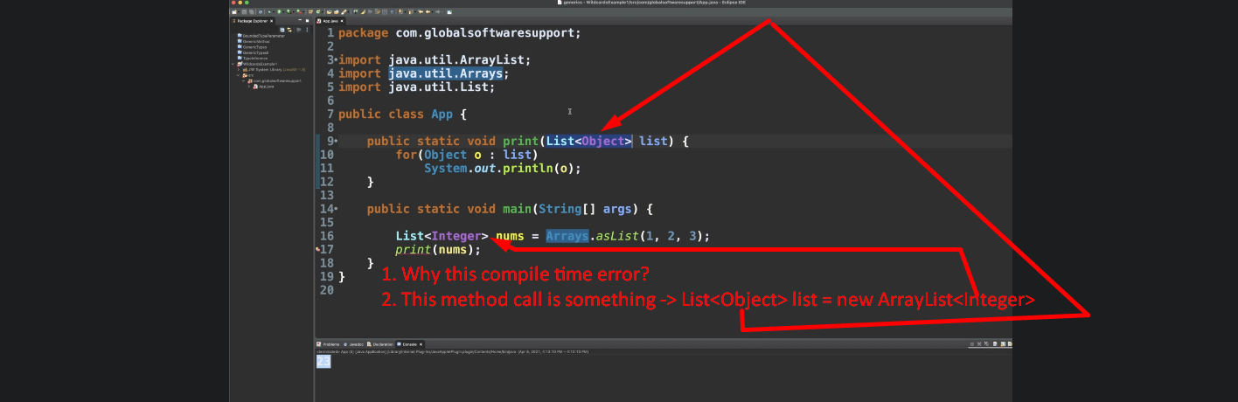
3. 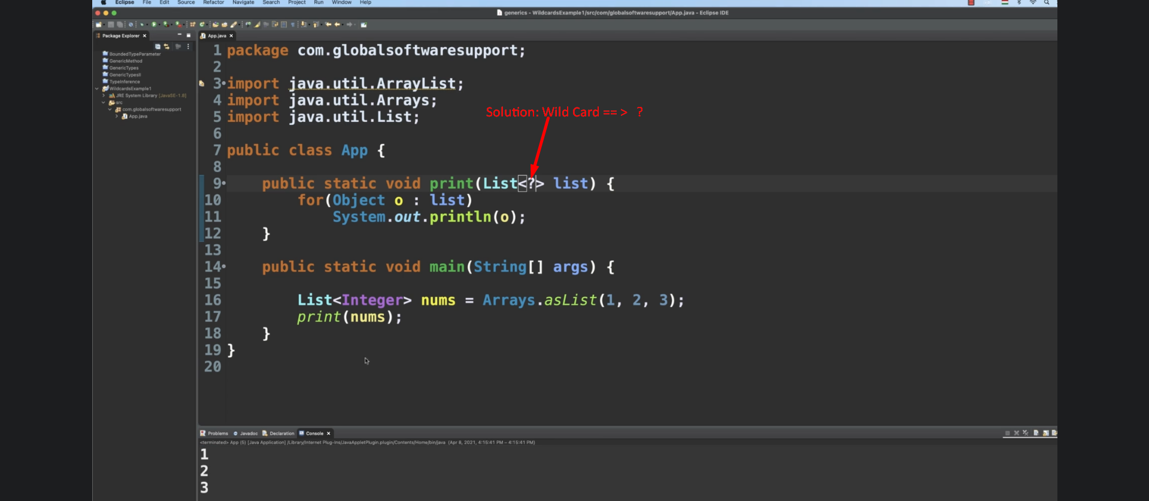
4. 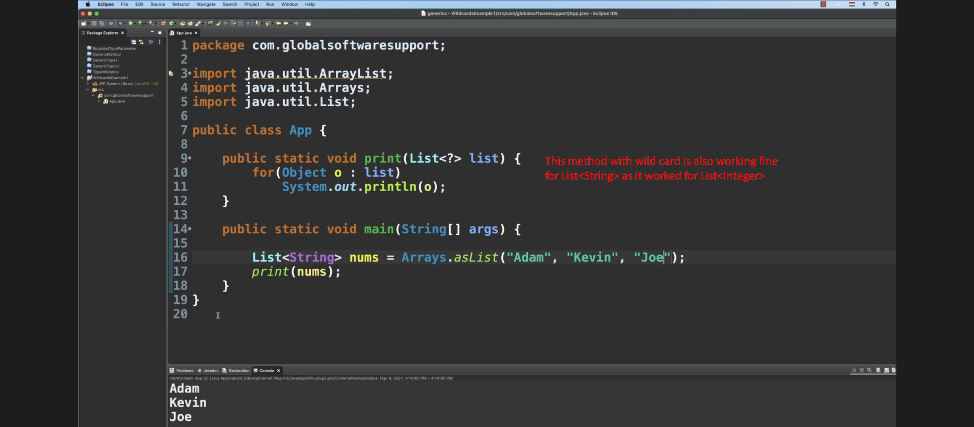
5. Another Example for Wild Card:
6. Let’s create interface Shape.  
   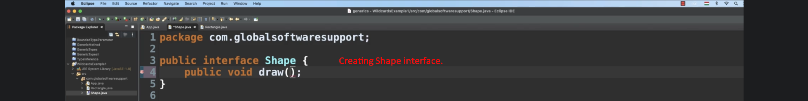
7. 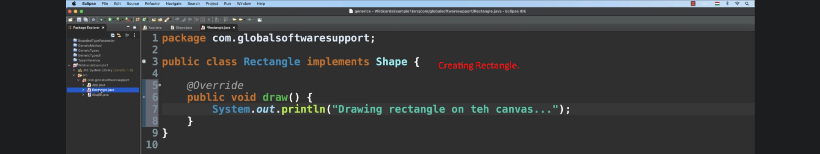
8. 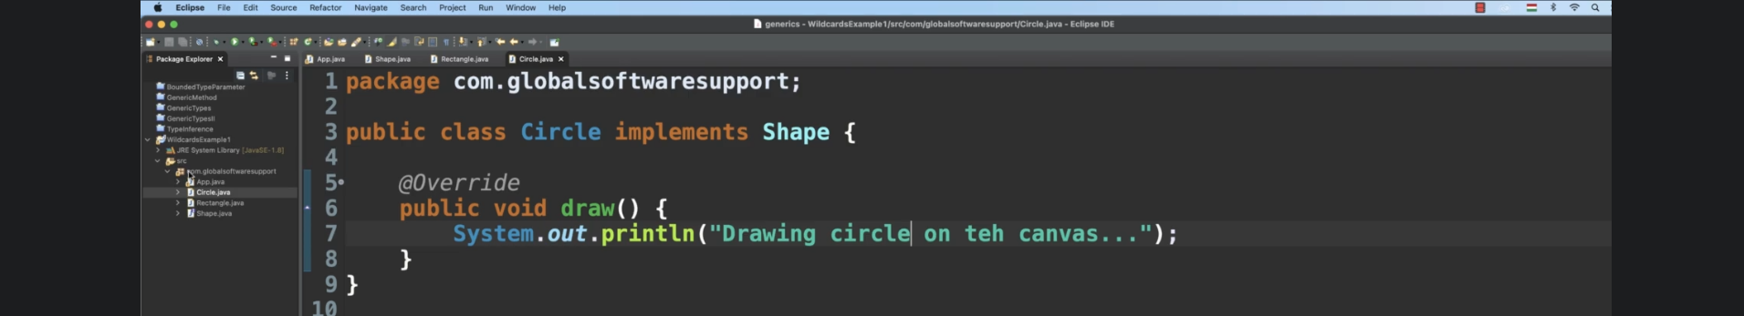
9. 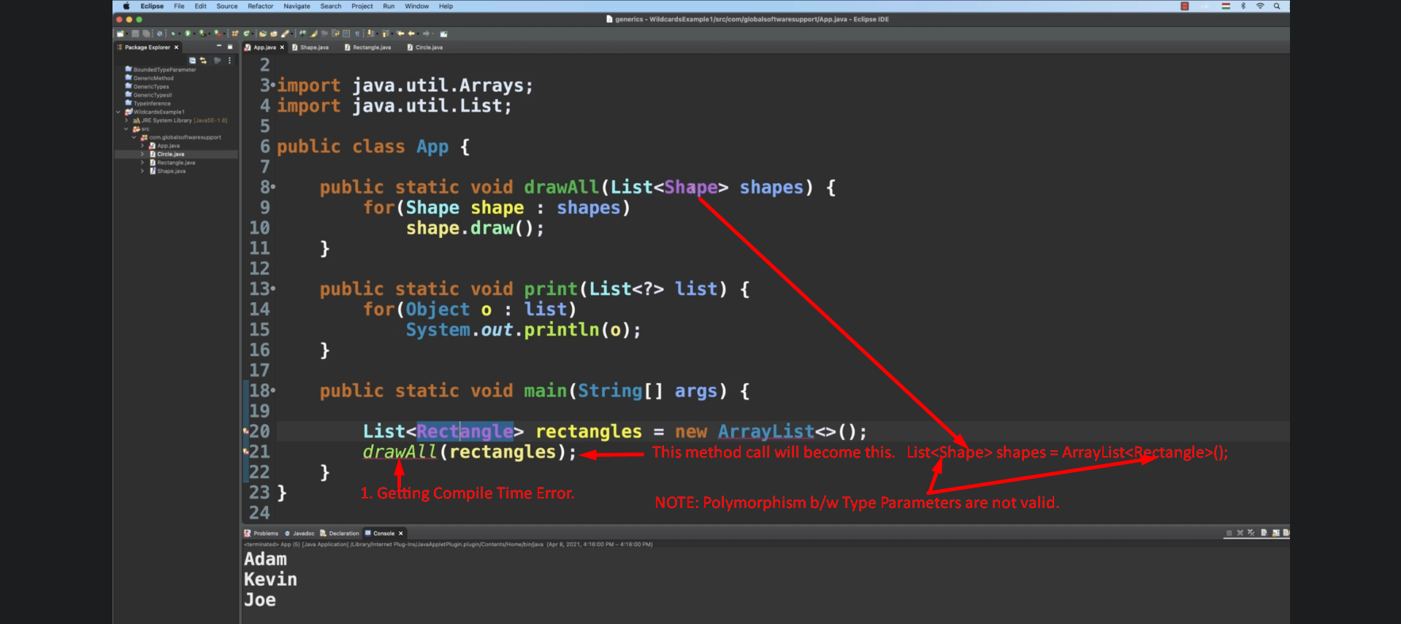
10. 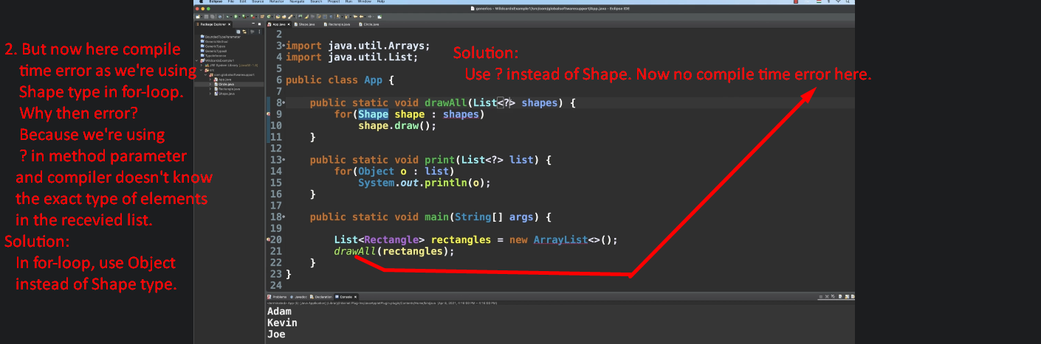
11. 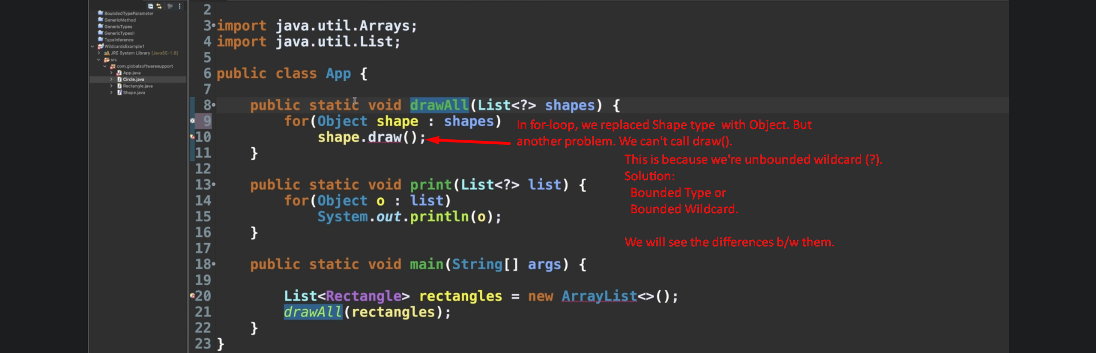
12. 